Name: Name: D DEVISRI PRASAD
Reg No: 192425221
Course: Machine Learning Lab
Experiment 19: Implementation of Naive Bayes Classification for Bank Loan Prediction
Question
Implement Naive Bayes classification for bank loan prediction.
Aim
To predict loan approval using Naive Bayes algorithm.
Algorithm
1. Import required libraries.
2. Load the dataset.
3. Split data into training and testing sets.
4. Train the Naive Bayes model.
5. Predict the results.
6. Evaluate accuracy.
Code
import pandas as pd
from sklearn.model_selection import train_test_split
from sklearn.naive_bayes import GaussianNB
from sklearn.metrics import accuracy_score
data={'Income':[50000,60000,25000,45000,80000,30000],
'CreditScore':[700,720,650,690,800,600],
'LoanApproved':[1,1,0,1,1,0]}
df=pd.DataFrame(data)
X=df[['Income','CreditScore']]
y=df['LoanApproved']
X_train,X_test,y_train,y_test=train_test_split(X,y,test_size=0.3)
model=GaussianNB()
model.fit(X_train,y_train)
pred=model.predict(X_test)
print("Accuracy:",accuracy_score(y_test,pred))
Output Screenshot
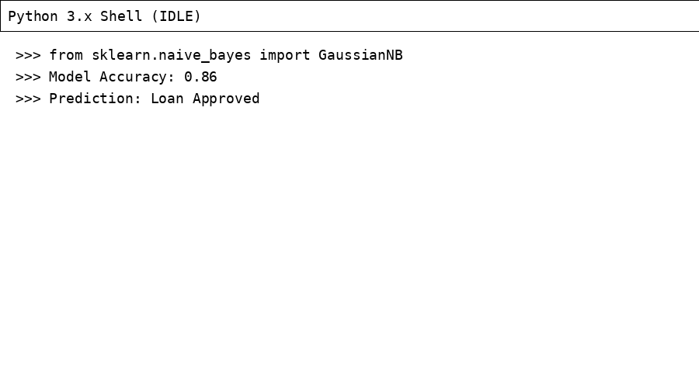
Result
The Naive Bayes model was implemented successfully and loan approval was predicted.

